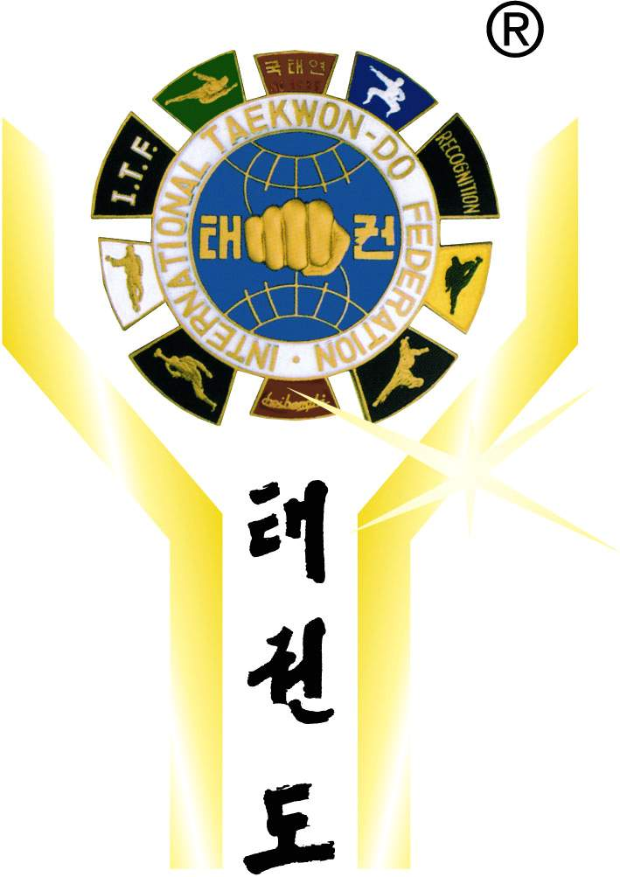 | International Taekwon-Do Federation  Deutschland e. V.  Founding member of I.T.F. 1966  Member of A.E.T.F. since 1982

President
Master Walter Komorowski
Ohligser Straße 40
40764 Langenfeld
 0212- 88166 28
 0212- 88166 29
E-mail: w.komorowski@itf-d.de
To all

ITF Federations, Clubs and Schools in Europe

Langenfeld, 24/03/2008

Subject: 1st Bavarian Open Championship
Dear Presidents, Masters, Instructors and Friends!

It is with great pleasure to announce that the ITF-Deutschland e.V. will host the

1st Bavarian Open Championship

to be held on June 7th, 2008 at Leonard-Wagner-School in Schwabmünchen. The Championship is open for B-Juniors 2. Gup and above 12-14 years, A-Juniors 2. Gup and above 15-17 years and Seniors 2. Gup and above + 18 years.
The official Sponsors of this tournament are BMW Müller & Klöck and Raiffeisenbank Schwabmünchen eG.

The reason for organizing this tournament is that in the last year, in the south of Germany, we convinced 5 new clubs from other Federations to join ITF Deutschland and we believe that we can convince more.
As you may know, the ITF officially recognized the Electronic Scoring System created by ITF-Germany for Patterns and Sparring at international ITF tournaments such as World Championships, World Cup and Continental Championships. This System will be used during the tournament and guarantees a fast tournament process.
We hope that you can join us in Schwabmünchen (near Augsburg) for this international tournament.
You will find further information attached.
Yours in TKD
Master Walter Komorowski
President ITF-Deutschland

